### **Task 1 : Basic Task**

**Open a linux terminal. Now do the following from the command line.**

1. Type in ls and press enter. What do you see? What does this mean?

= The Terminal has shown me the list of files in the directory I am currently in.

1. **Type in pwd and press enter. What do you see? What does this mean?**

= The Terminal shows me the actual directory that I am currently in and my user name on the machine I am using. It means I am in the Present Working Directory

1. **Make a new directory called workspace then cd into your new directory**

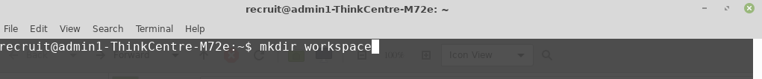



1. **Type in ls and press enter. What do you see? What does this mean?**

= The Terminal is showing me the list of files inside the folder/directory

workspace.

It means I haven’t inserted/created anything inside the Directory.

1. **Make a new file called README.md (you can use the touch command to do this)**

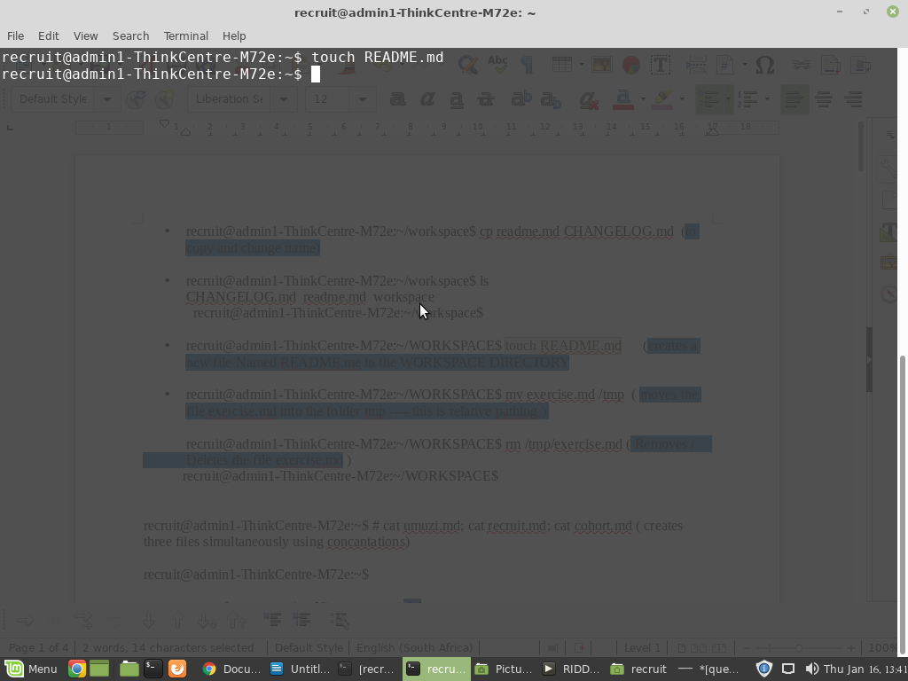

1. **Make a copy of README.md, name your copy CHANGELOG.md**

